Take another look at the ERD, add as many details as needed, including attributes for each table, make any revisions as needed.

Once you have your tables in finalized state, write the Python script to create the tables in MySQL, and populate each with at least 6 records (fewer if noted in the case study, for example only three suppliers noted at Bacchus Winery).

Write a python script that displays the data in each table, and take a screenshot of the results of the script that displays the data in each table.

**Entity Relationship Diagram:**

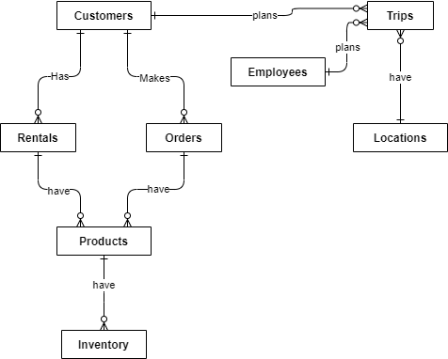

**Revised Entity Relationship Diagram:**